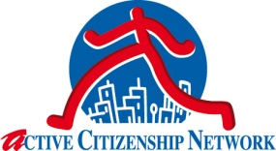

TO: DG SANCO Health care Systems Unit
The cross-border healthcare team
Natalie Chaze, Kari Steig
SANCO-Cross-Border-Healthcare@ec.europa.eu
Informative leaflet on the Directive 24/2011
(name of your Association) subscribed the Manifesto for the implementation of the Right of European Patients to make an informed choice, promoted in May 2013 by Active Citizenship Network, and decided to work at national level to share to the public the chance deriving from the implementation of the Directive.
We herewith kindly ask to receive (number) of informative leaflet 'To know before you go' in (your/available language) in order to share it in (your Country, or region or headquarters or…etc) and collaborate to inform citizens on their “European rights”.

We will keep you informed (directly or through Active Citizenship Network) about any public event we will realize (events, conferences, meetings in the hospitals, etc.).

Thank you in advance
Best regards

Name Surname
Association
Country
Detailed postal contacts

www.activecitizenship.net

http://www.activecitizenship.net/patients-rights/29-news/116-manifesto-for-the-implementation-of-the-right-of-european-patients-to-make-an-informed-choice.html

